Quick Guide to Activating ELD Tracking in BY Network

March 27, 2026
Version 1.1.6

ONE Network Driver Application User Guide –Driver Operations
1
Table of Contents

1 Introduction 3
2 Activating ELD Tracking 3
2.1 Authorizing ELD Provider Connection 3
2.2 Confirming Successful Authorization 8
3 Assigning Vehicles to Shipments 10
3.1 Single Shipment Assignment 10

Introduction
This guide provides instructions for transportation providers to activate ELD tracking in the One Network system. This allows your company to authorize ELD providers to transmit truck locations into One Network, enabling real-time visibility into shipments for your customers.

Benefits of ELD tracking:

- Real-time visibility of in-transit shipments.
- Proof of pickup and delivery with geolocation data.
- Increased efficiency and load oversight.

Activating ELD Tracking
This section covers how to authorize third-party ELD providers to connect with One Network to transmit truck location data.

Authorizing ELD Provider Connection

- Login to the One Network system with the Carrier Manager role.
https://rtvn9499.onenetwork.com/

- 2. Select **Contract Mgmt --> ELD Authorization** as shown below:

- On the left side, select the ELD provider your company works with.
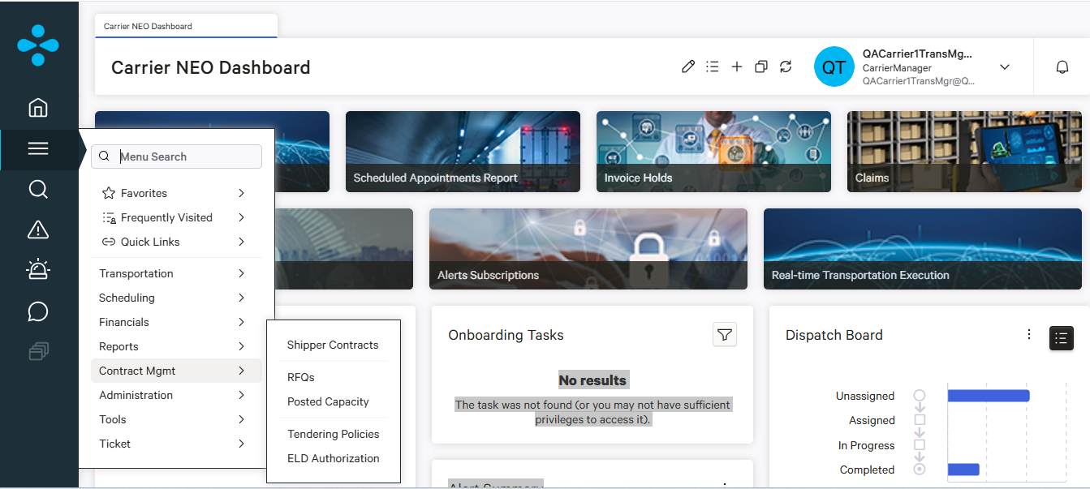

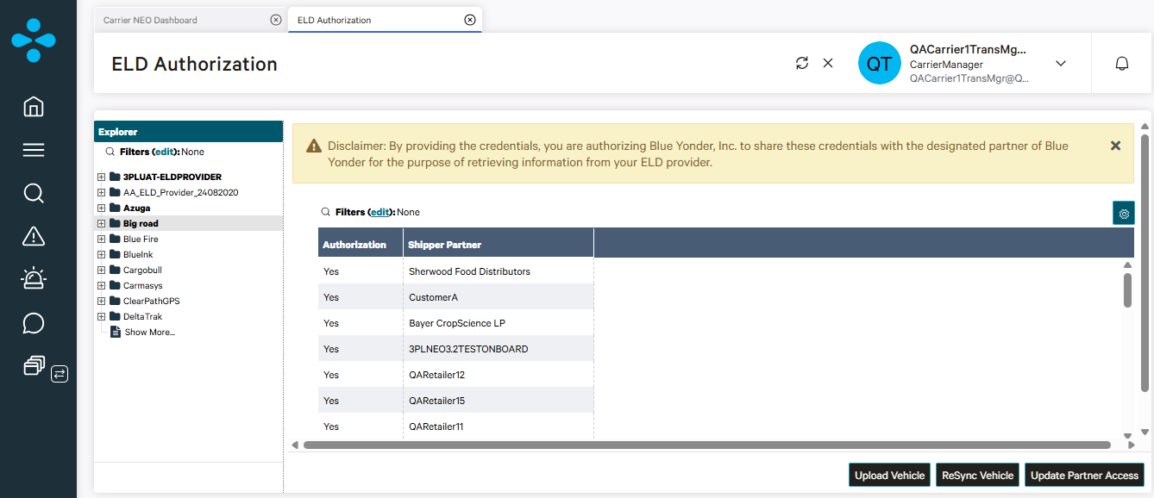

- Click **Authorize**. This will bring up the Integration Partner Authorization page.

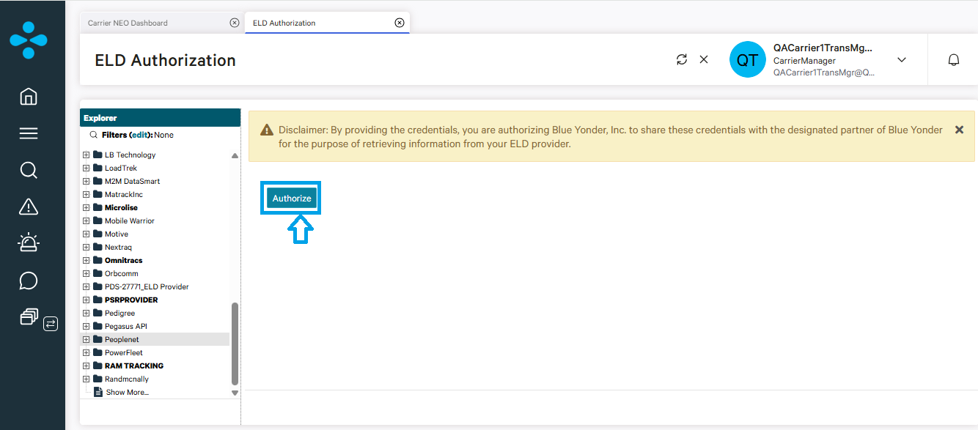

- **Terms & Conditions** - You can click the link to view, but no acceptance checkbox is needed.

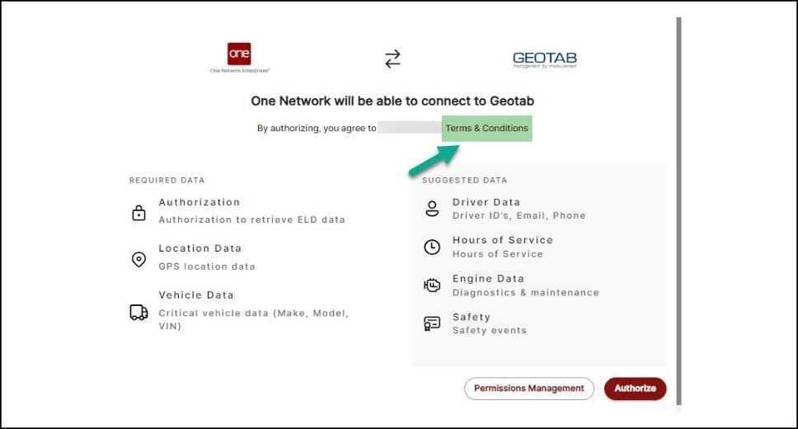

- **Required Data** - Provider info that is needed.

- **Suggested Data** - Optional additional data.

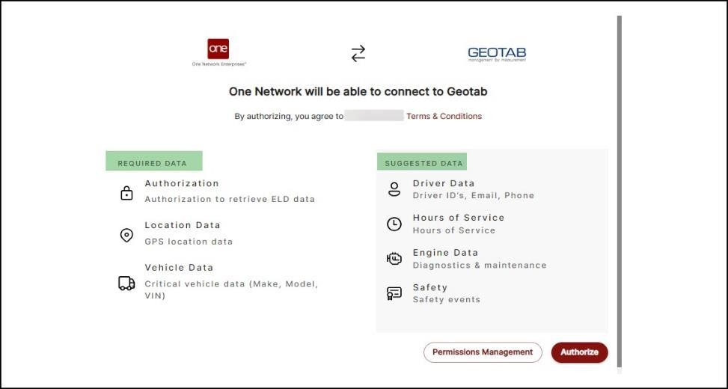

- **Verify Credentials** - Options:

  - Enter **Username** and **Password**
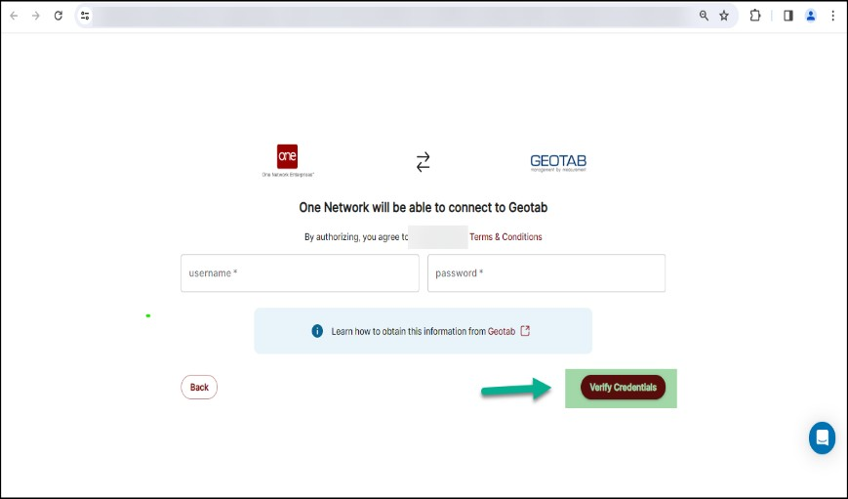

  - Enter **API Key**
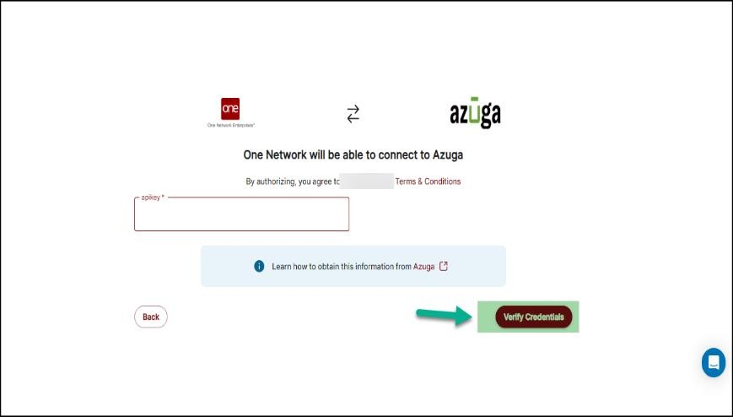

  - Click provided **ELD Onboarding Guides** link to view provider tutorials.

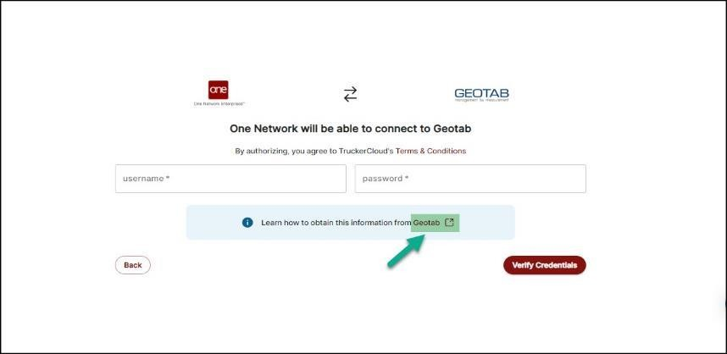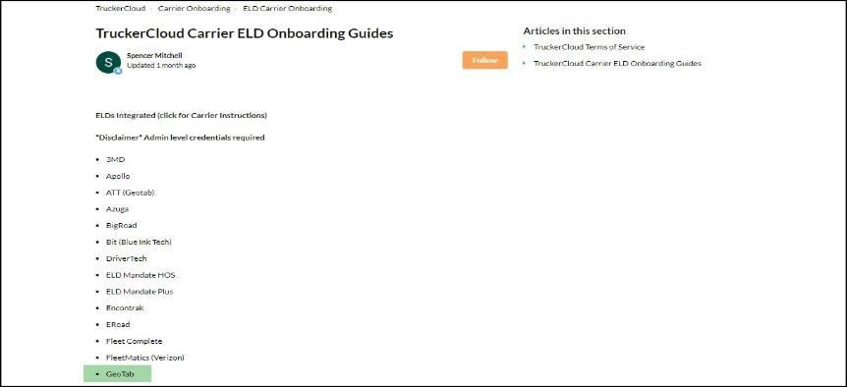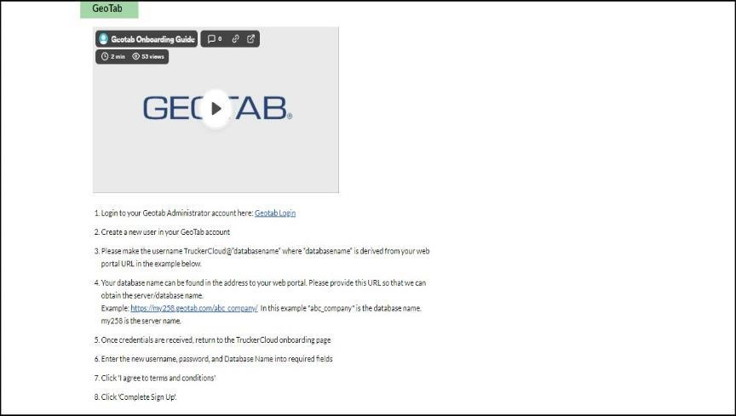

  - Click **Verify**.

Confirming Successful Authorization

- The ELD provider name will now appear in bold font, indicating successful authorization.

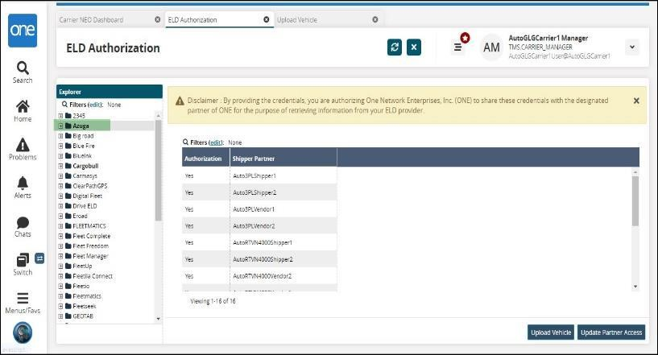

Note: - “After authorization is complete, please wait for your ELD provider to sync your vehicles to the Blue Yonder platform automatically.”

Assigning Vehicles to Shipments
This section covers how to link specific vehicles to shipments for ELD tracking visibility.

Single Shipment Assignment

- Select the shipment(s) you want to assign.
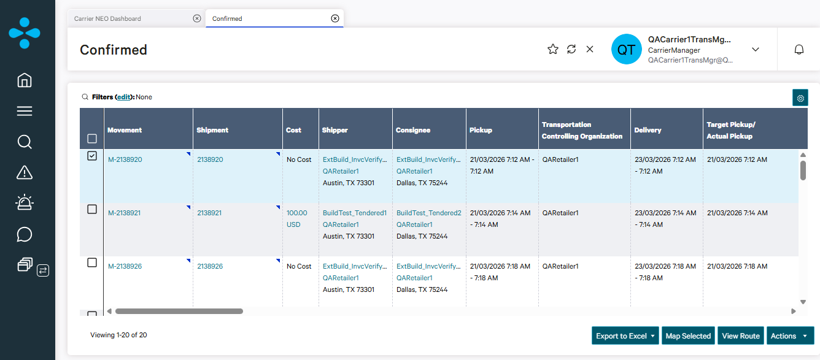

- Click **Actions -> Assign Vehicle**.
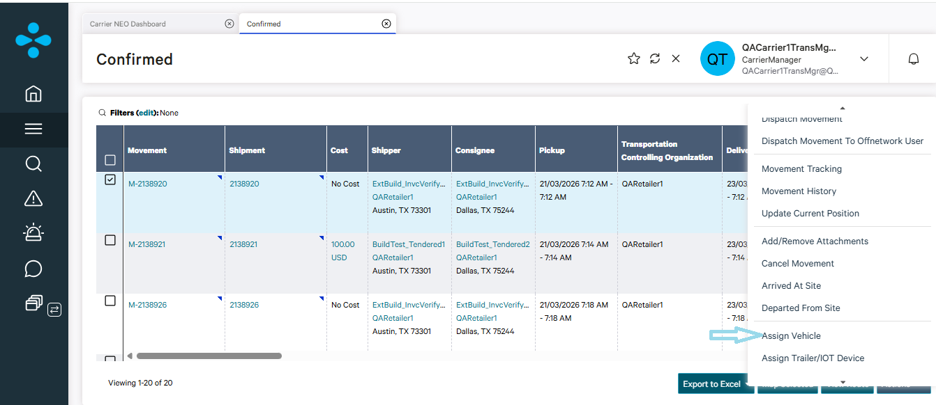

- Enter the **Carrier Vehicle/Trailer** number.
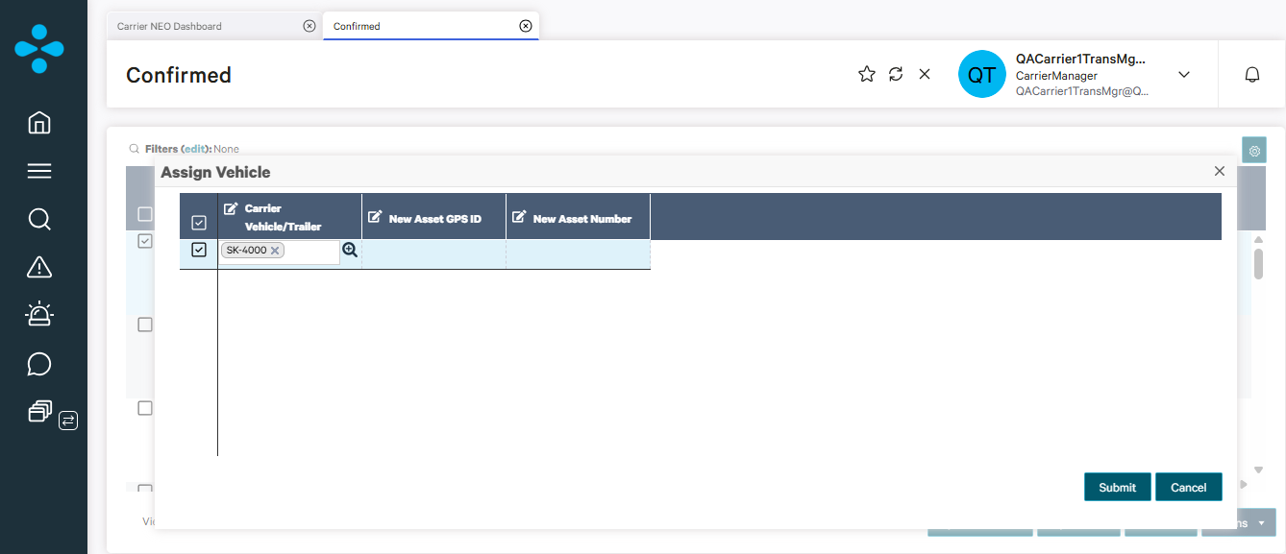

- Click **Submit**.
